ANOTHER SLAVE ON THE RUN!!

During the night, a local slave named Harriet Ross escaped from her owner (Declan Hargreeves). She escaped from Hard plantation.

The day before had been normal. All the slaves got up on the crack of dawn like usual, reported Declan Hargreeves. They were picking cotton, ploughing the fields and loading produce into wagons. all day until nightfall where all slaves - including Harriet- went back to the cabin to sleep.The next day, the master was counting the slaves' heads when Harriet was nowhere to be seen.The master thought she already got out of town (Notpool). So the master decided to contact local slave catchers.

We then spoke to the master who exclaimed, “I am furious! I want my property back! I shall give $5 to whoever finds her! Next we spoke to a slave catcher(Don't get caught) informed us “ We will not stop. We have never lost a slave, some killed but never lost at least I'm still gettin paid.” A bystander claimed” I saw a slave runnin into the forest but I didn't think of it. She was probably just runnin around.”

The mother ,also called Harriet, told us that it was selfish for her to leave and it was devastating for her.Slave capture called Don't get caught told us that there dogs wouldn't stop at nothin to get Harriet back.Another slave said that even if he knew where she was he wouldn't tell anyone.The slave owner said that Harriet was making her mother heartbroken.Currently no one has found her, any sightings or information about Harriet's escape please go to your sheriff's office, Hard plantation or local slave catchers.

She is still at large.This is her picture. Please turn her in if you see her.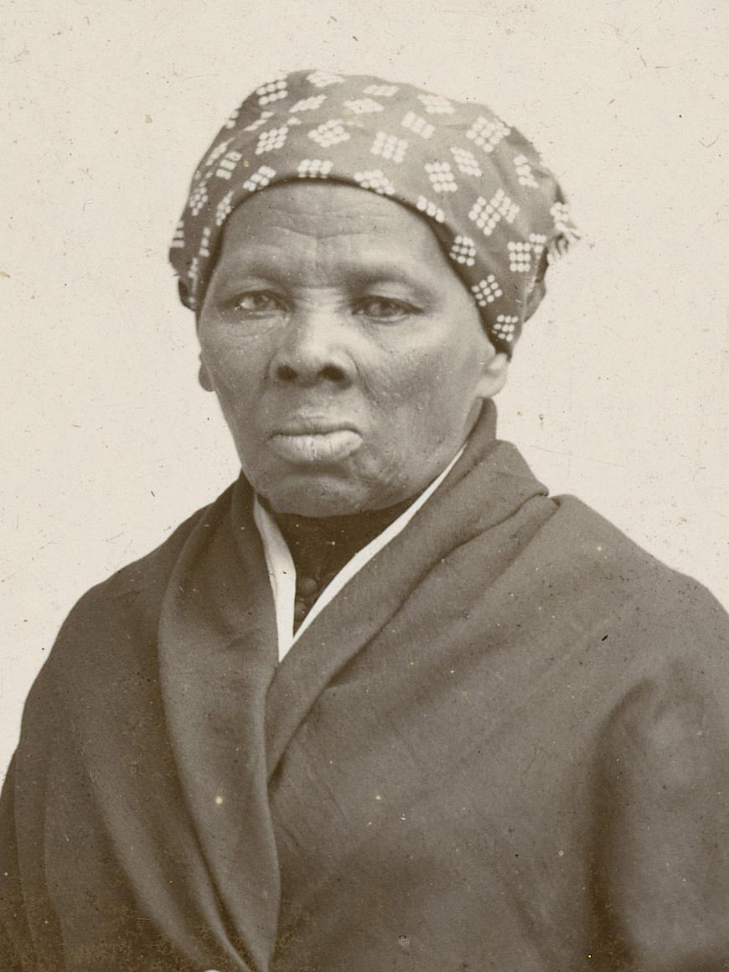

Kyron Bolger.